Meeting Notes

We primary use the sprint documents to record what we have discussed during our meetings. This will serve as a simple summary for each meeting and other important notes.

# 12/2/21

* First meeting
* Initial analyse and design of the coursework specification
* Dedicate tasks to each members depending on skill level
* Tomasz and Mohammad will spend the first few weeks learning unity using Brackey’s video
* <https://www.youtube.com/watch?v=IlKaB1etrik&ab_channel=Brackeys>

# 26/2/21

* We have managed to let the player to select a tile to move to
* Board generation looking good and editable via the CSV file.
* Asked Tom to work on the UI as it doesn’t involve much C# coding and mostly drag and drop UI elements

# 05/3/21

* Decided to work on to get movement to work
* Planning to take a break from the project so 3 of us can work on the 3D modelling coursework

# 19/03/21

* The lamp model is done
* Movement seems to be done
* Decided to work on accusation as the UI used in that can be reused for suggestion

# 13/04/21

* Meeting at the last week of easter
* No one wants to work XD
* Accusation seems to be working, some UI seems to be a bit broken
* Moving on to suggestion

# 19/04/21

* 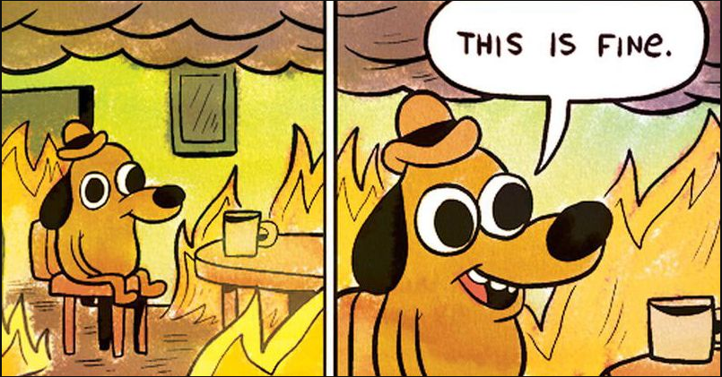
* Post Easter meeting
* UI is broken, accusation does not work, errors every where
* Missing multiple important functionality
* What we have:
* Gantt chart
  + Missing risk assessment
* Class diagram
  + Only one single high level diagram for the overall system
* UML
  + Movement
  + Check shortcut
  + Suggestion
  + Accusation
  + Board generation
  + Showing movable tiles
* Sprint cycle docs
  + We have 5
  + Missing refinements
* Testing
  + Test scene
    - Room entry scene
    - Player shortcut test scene
    - Dice scene
    - Movement scene
    - Suggestion scene
  + Polish and finalise Testing documents for all the scene
* Functionality:
  + Board generation
  + Dice rolling
  + Player movement selection
  + Room entry
  + Turn control
  + Code for suggestion and accusations
  + Free roll tile
* Things to do today:
  + Suggestion test scene
    - Dealing more cards than it should be
  + Fix the Card UI again
* Will meet again tomorrow

# 20/04/21

* Missing functionalities:
  + Showing suggested cards from player
    - Display and click on card to be suggested
    - Move the suggested stuff
  + Game win screen
  + Player eliminated screen
  + Getting bonus tiles to work
    - Mainly Suggestion
  + Remake Suggestion to take room when landing on that tile
  + AI
    - PAIN
    - Design AI logic
    - Design UML
    - Implementation of logic
      * Rolling and moving tiles
      * Getting to a room
      * Making suggestions
        + Randomly
      * Handle showing cards
        + Randomly
      * Making Accusations when ready
  + Game customization
    - Set number of players and AI
    - Choose which player is which character

# 22/04/21

* Added sprite to card class
* Making new Enum to string converter
* Got new UI
* Added AI
* Remade suggestion and accusation menu
* Need to do:
  + Game win (Done)
  + Game over (Done)
  + Detective notepad
  + Game manager (Done)
  + AI stepping on extra suggestions tile
* Meeting with Mr Raffles
* Things to ask:
  + We are in crunch mode
  + Showing suggestion
  + Suggestion tile
  + Movement doesn’t cost to enter a room
  + How fill out sprint properly
  + Multiple deceives
* Raffles suggestion:
  + Demo button
    - Have 6 AIs to play to show how the game plays
* Responds:
  + Testing
    - Organize component testing to the scene
    - Possible actions it can do and what it is expected and if it pas or fail
    - System level testing depending on the Clue Rules
    - Cross checking with the component requirements
    - Have it run non stop, reliability testing
  + Peer assessment
    - None zero for Mohammod
      * Minimal engagement
  + Class diagram
    - Update it

# 26/04/21

* All game function done
* Docs to do:
  + Finalize testing tables
    - Movement
    - AI
    - UI
  + Finalize System testing table
  + Document all major scripts
  + Update class diagram
    - Use the fully generated doc to help
  + Smarten up sprint cycles
    - Add User story back
    - Add diagram design and associated UML
    - Link corresponding testing scene to testing
  + Create summary meeting notes
  + Finalise sprint 6
    - Explain we have enter surge/ crunch
    - Add finalizing documents and report
  + Main report
    - Includes all notes including